Name: B C Yugesh Reg no: 192424282
Course Code: DSA0604
Lab Experiments
Set 1
Program 1: Line Chart for Monthly Sales
month <- c("January", "February", "March", "April", "May")
sales <- c(15000, 18000, 22000, 20000, 23000)
plot(sales,
type = "o",
xaxt = "n",
xlab = "Month",
ylab = "Sales ($)",
main = "Monthly Sales",
col = "blue",
lwd = 2,
pch = 16)
axis(1, at = 1:5, labels = month)
grid()
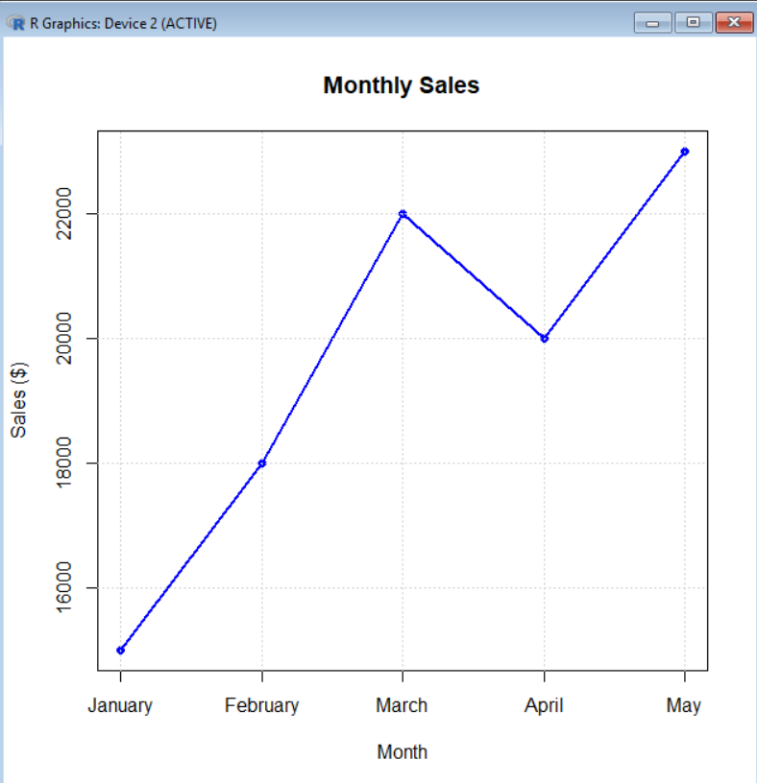
Output:

Program 2: Bar Chart for Top-Selling Products
products <- c("Laptop", "Mobile", "Tablet", "Headphones", "Smartwatch")
sales <- c(120, 180, 90, 150, 100)
barplot(sales,
names.arg = products,
col = "skyblue",
main = "Top Selling Products",
xlab = "Products",
ylab = "Units Sold",
border = "black")

Output:
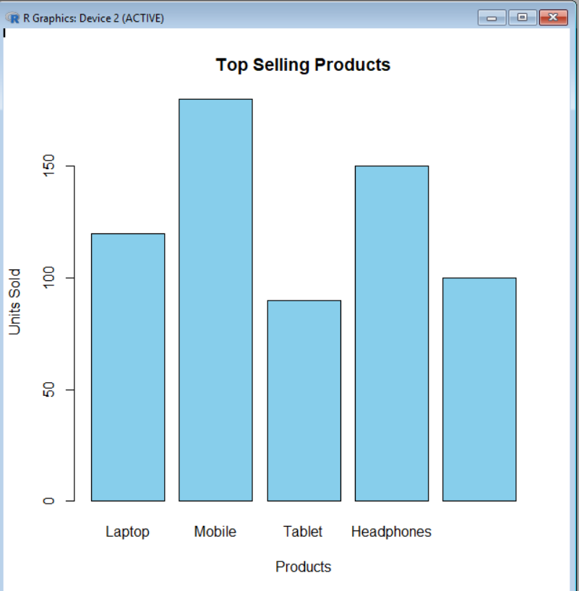

Program 3: Scatter Plot (Advertising Budget vs Monthly Sales)
advertising <- c(2000, 2500, 3000, 2800, 3500)
sales <- c(15000, 18000, 22000, 20000, 23000)
plot(advertising,
sales,
main = "Advertising Budget vs Sales",
xlab = "Advertising Budget ($)",
ylab = "Monthly Sales ($)",
pch = 19,
col = "red")
abline(lm(sales ~ advertising), col = "blue", lwd = 2)

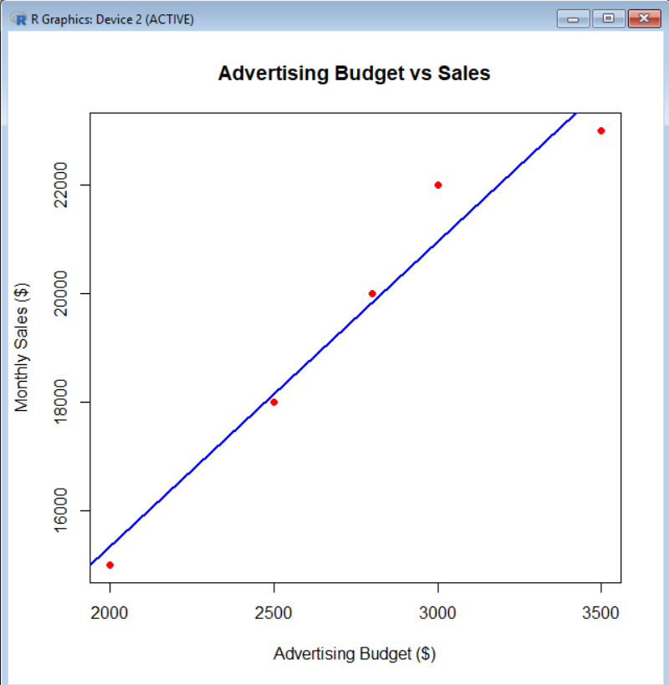
Output:

Program 4: Interactive Dashboard (Line Chart + Bar Chart)
install.packages("manipulate")
library(manipulate)
month <- c("January", "February", "March", "April", "May")
sales <- c(15000, 18000, 22000, 20000, 23000)
manipulate(
{
par(mfrow = c(1,2))
plot(sales,
type = "o",
xaxt = "n",
xlab = "Month",
ylab = "Sales ($)",
main = "Monthly Sales",
col = "blue",
lwd = 2,
pch = 16)
axis(1, at = 1:5, labels = month)
barplot(sales,
names.arg = month,
col = "lightgreen",
main = "Monthly Sales Bar Chart",
xlab = "Month",
ylab = "Sales ($)")
},
dummy = slider(1,5,initial = 1))
Output:
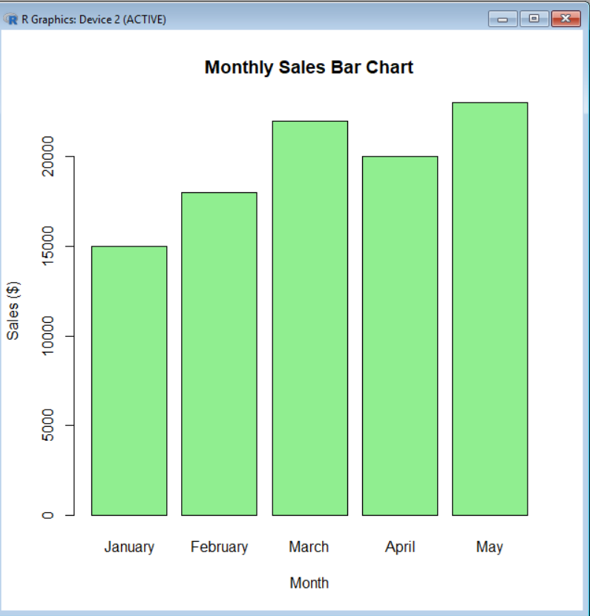

Set 2

Program 1: Histogram of Customer Ages
age <- c(25, 30, 35, 28, 40)
hist(age,
main = "Distribution of Customer Ages",
xlab = "Age",
ylab = "Frequency",
col = "skyblue",
border = "black")

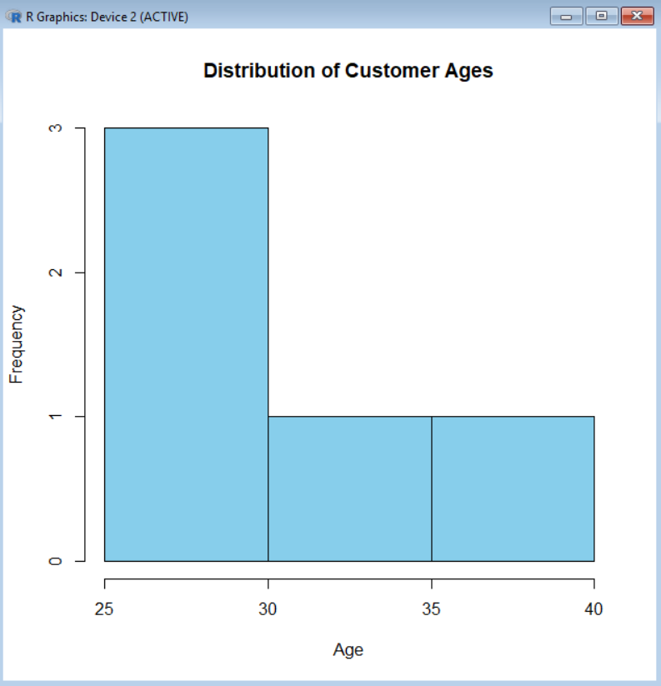
Output:

Program 2: Pie Chart of Customer Satisfaction Scores
customer_id <- c(1,2,3,4,5)
age <- c(25,30,35,28,40)
satisfaction <- c(4,5,3,4,5)
data <- data.frame(customer_id, age, satisfaction)
score_count <- table(data$satisfaction)
pie(score_count,
main="Customer Satisfaction Scores",
labels=paste(names(score_count), "(", score_count, ")", sep=""),
col=rainbow(length(score_count)))

Output:
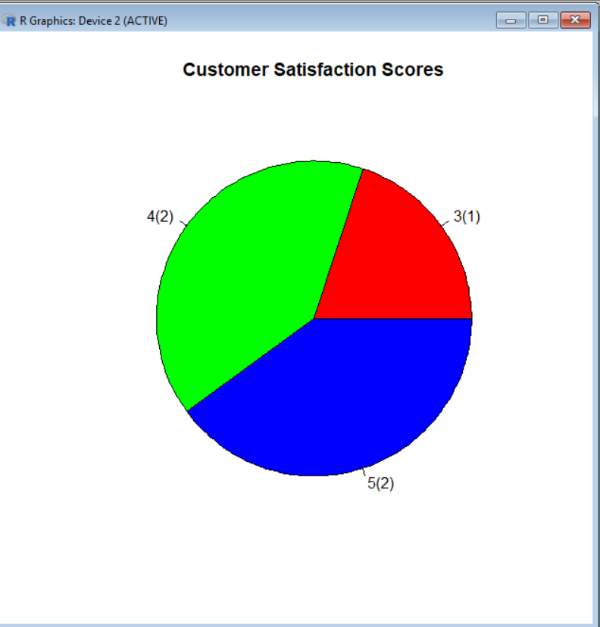

3. Stacked Bar Chart of Satisfaction Scores by Age Group
customer_id <- c(1,2,3,4,5)
age <- c(25,30,35,28,40)
satisfaction <- c(4,5,3,4,5)
data <- data.frame(customer_id, age, satisfaction)
data$AgeGroup <- cut(data$age,
breaks=c(20,30,40,50),
labels=c("21-30","31-40","41-50"),
include.lowest=TRUE)
table_data <- table(data$AgeGroup, data$satisfaction)

barplot(table_data,
main="Satisfaction Scores by Age Group",
xlab="Age Group",
ylab="Number of Customers",
col=rainbow(ncol(table_data)),
legend=colnames(table_data))

Output:

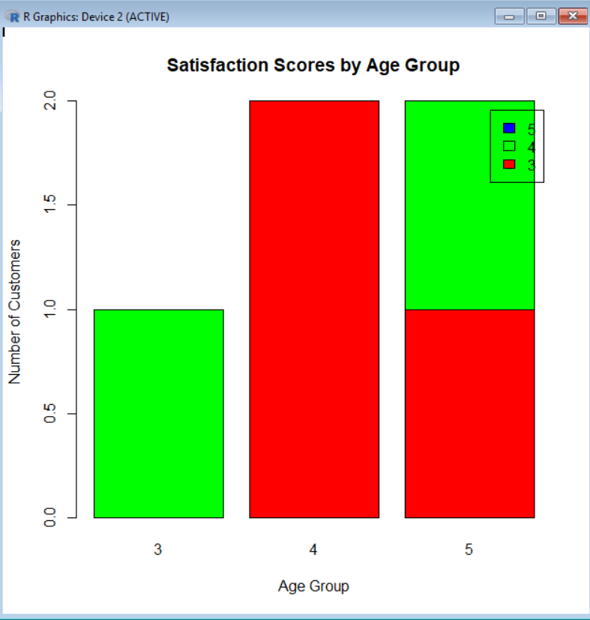

Set 3
Program 1: Line Chart – Performance Trend of Employees
EmployeeID <- c(1,2,3,4,5)
Department <- c("Sales","HR","Marketing","Sales","HR")
YearsService <- c(5,3,7,4,2)
PerformanceScore <- c(85,92,78,90,76)
data <- data.frame(EmployeeID, Department, YearsService, PerformanceScore)
plot(data$YearsService,
data$PerformanceScore,
type="o",
col="blue",
pch=16,
xlab="Years of Service",
ylab="Performance Score",
main="Employee Performance Trend")
legend("bottomright",
legend="Performance",
col="blue",
lty=1,
pch=16)

Output:
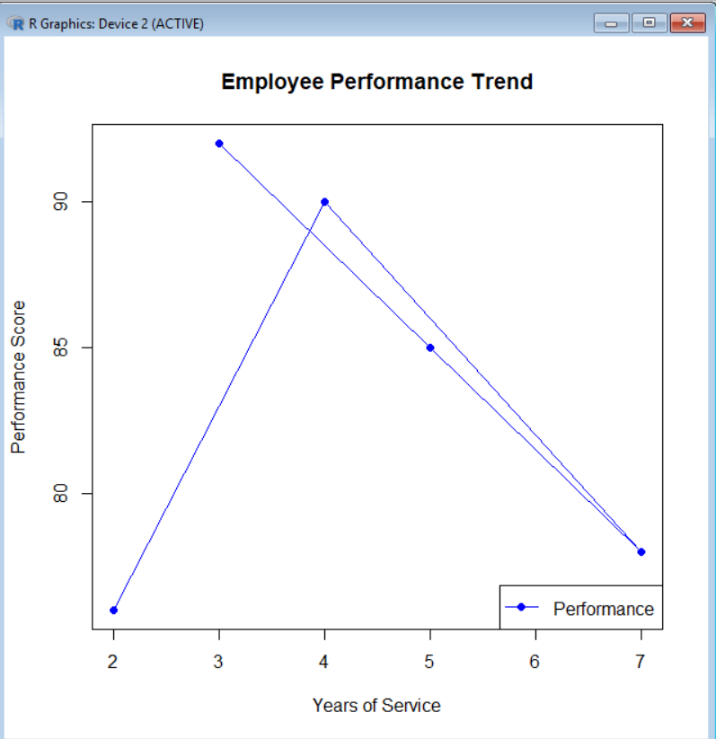

Program 2: Bar Chart – Employees by Department
EmployeeID <- c(1,2,3,4,5)
Department <- c("Sales","HR","Marketing","Sales","HR")
YearsService <- c(5,3,7,4,2)
PerformanceScore <- c(85,92,78,90,76)
data <- data.frame(EmployeeID, Department, YearsService, PerformanceScore)
dept_count <- table(data$Department)

barplot(dept_count,
col=c("skyblue","orange","green"),
main="Employees by Department",
xlab="Department",
ylab="Number of Employees")

Output:
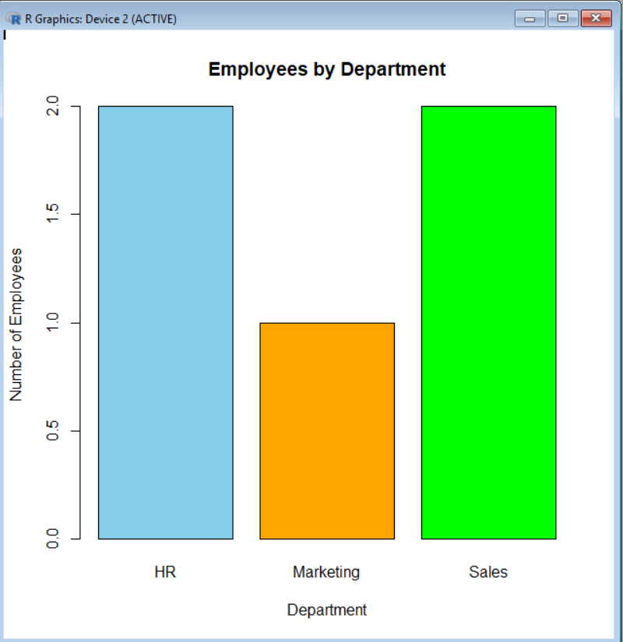

Program 3: Scatter Plot – Years of Service vs Performance Score
EmployeeID <- c(1,2,3,4,5)
Department <- c("Sales","HR","Marketing","Sales","HR")
YearsService <- c(5,3,7,4,2)
PerformanceScore <- c(85,92,78,90,76)
data <- data.frame(EmployeeID, Department, YearsService, PerformanceScore)
plot(data$YearsService,
data$PerformanceScore,
pch=19,
col="red",
xlab="Years of Service",
ylab="Performance Score",
main="Years of Service vs Performance Score")
abline(lm(PerformanceScore ~ YearsService, data=data),
col="blue",
lwd=2)

Output:
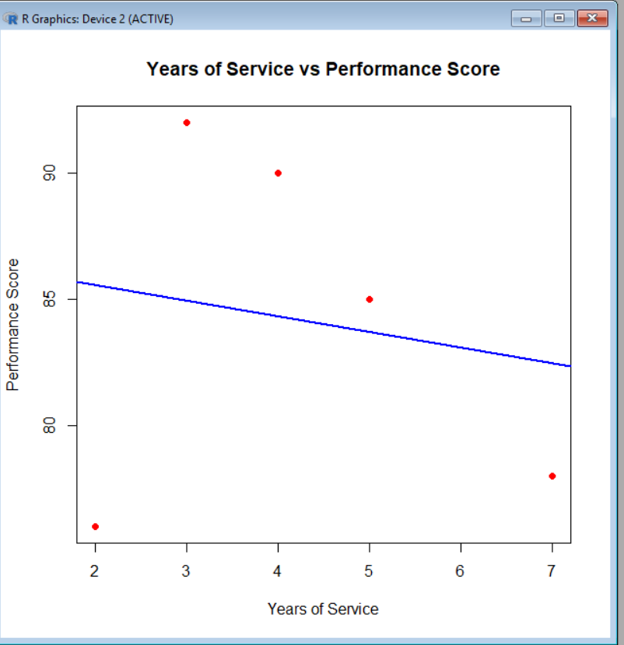

Program 4: Interactive Dashboard (Using plotly)
library(plotly)
EmployeeID <- c(1,2,3,4,5)
Department <- c("Sales","HR","Marketing","Sales","HR")
YearsService <- c(5,3,7,4,2)
PerformanceScore <- c(85,92,78,90,76)

data <- data.frame(EmployeeID, Department, YearsService, PerformanceScore)
fig <- plot_ly(data,
x=~YearsService,
y=~PerformanceScore,
type="scatter",
mode="lines+markers",
color=~Department)
fig

Output:

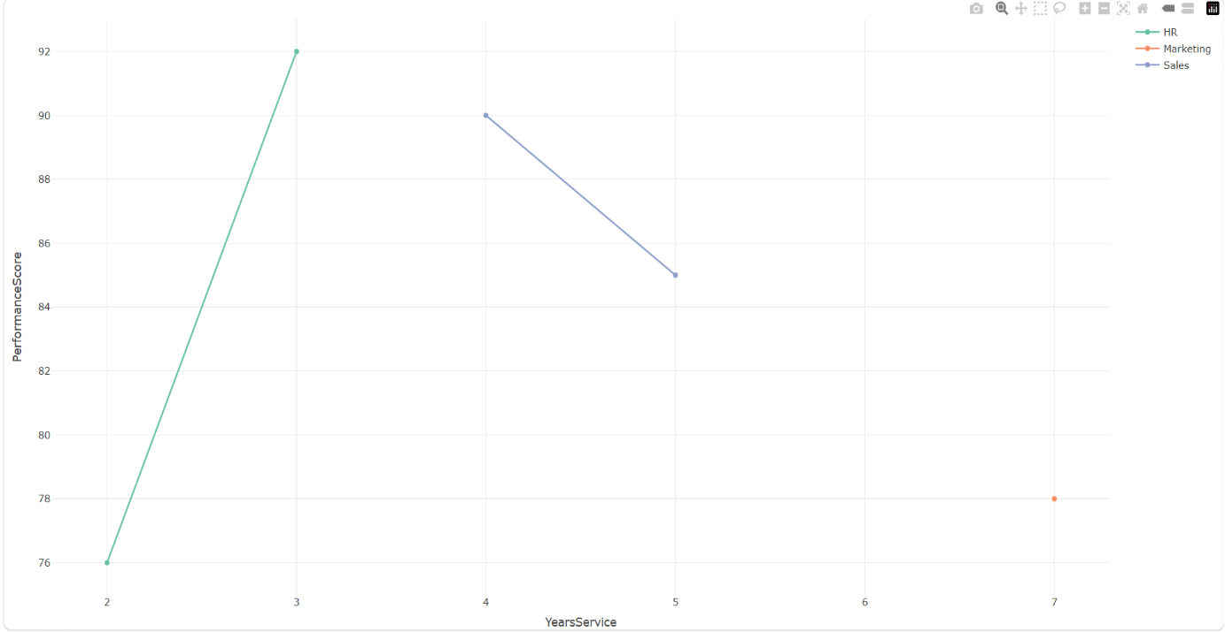

Set 4
Program 1: Bar Chart – Quantity of Each Product
ProductID <- c(1,2,3,4,5)
ProductName <- c("Product A","Product B","Product C","Product D","Product E")
QuantityAvailable <- c(250,175,300,200,220)
data <- data.frame(ProductID, ProductName, QuantityAvailable)
barplot(data$QuantityAvailable,
names.arg=data$ProductName,
col="skyblue",
main="Quantity of Products in Inventory",
xlab="Product Name",
ylab="Quantity Available")

Output:
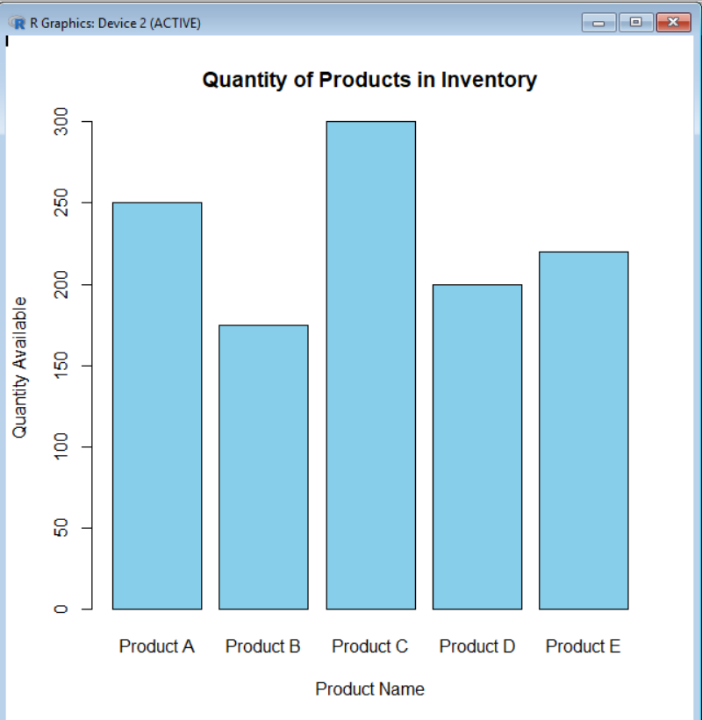

Program 2: Stacked Bar Chart – Product Quantity by Category
ProductID <- c(1,2,3,4,5)
ProductName <- c("Product A","Product B","Product C","Product D","Product E")
QuantityAvailable <- c(250,175,300,200,220)
Category <- c("Electronics","Electronics","Furniture","Furniture","Electronics")
data <- data.frame(ProductID, ProductName, QuantityAvailable, Category)
table_data <- tapply(data$QuantityAvailable,
data$Category,
sum)
barplot(table_data,
col=c("orange","green"),
main="Inventory Quantity by Category",
xlab="Category",
ylab="Total Quantity")
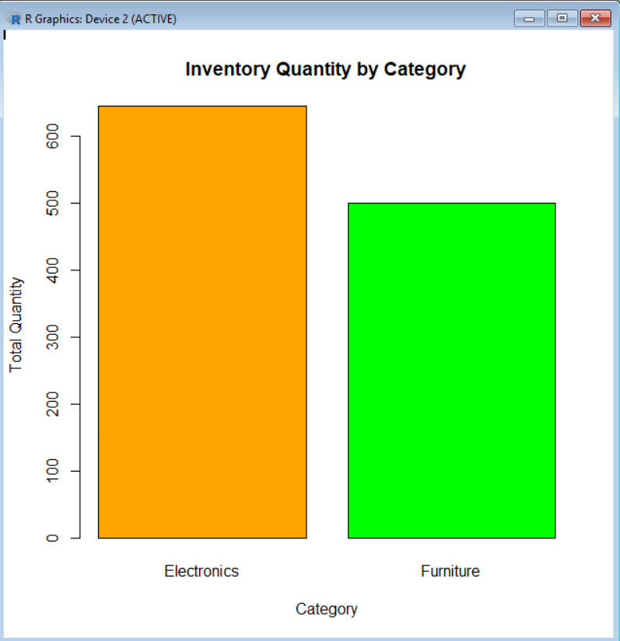
Output:

Program 3: Scatter Plot – Product ID vs Quantity Available
ProductID <- c(1,2,3,4,5)
ProductName <- c("Product A","Product B","Product C","Product D","Product E")
QuantityAvailable <- c(250,175,300,200,220)
data <- data.frame(ProductID, ProductName, QuantityAvailable)
plot(data$ProductID,
data$QuantityAvailable,
pch=19,
col="red",
xlab="Product ID",
ylab="Quantity Available",
main="Product ID vs Quantity Available")
abline(lm(QuantityAvailable ~ ProductID, data=data),
col="blue",
lwd=2)
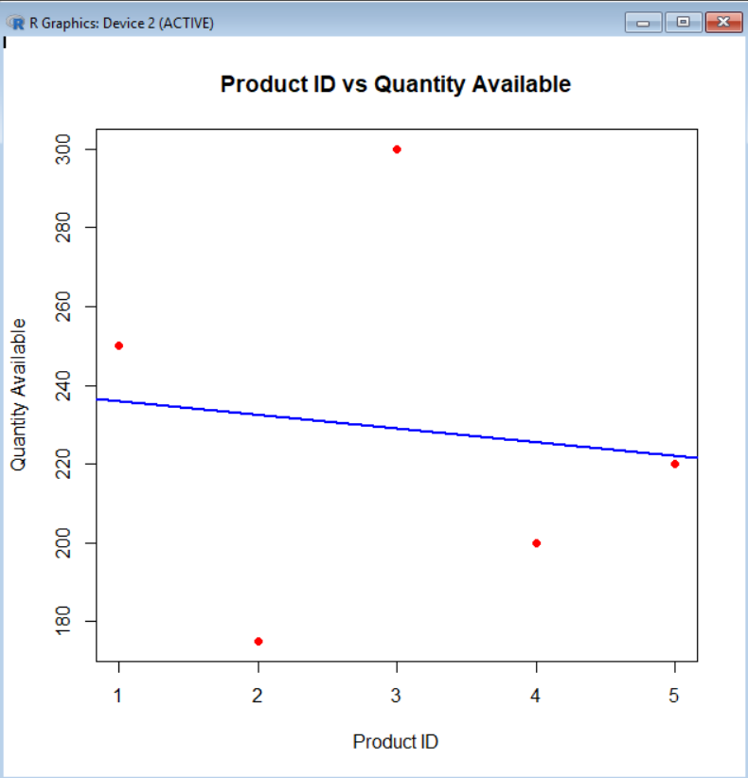
Output:

Program 4: Interactive Dashboard (Plotly)
library(plotly)
ProductID <- c(1,2,3,4,5)
ProductName <- c("Product A","Product B","Product C","Product D","Product E")
QuantityAvailable <- c(250,175,300,200,220)
data <- data.frame(ProductID, ProductName, QuantityAvailable)
fig <- plot_ly(data,
x=~ProductName,
y=~QuantityAvailable,
type="bar",
marker=list(color="steelblue"))
fig

Output:
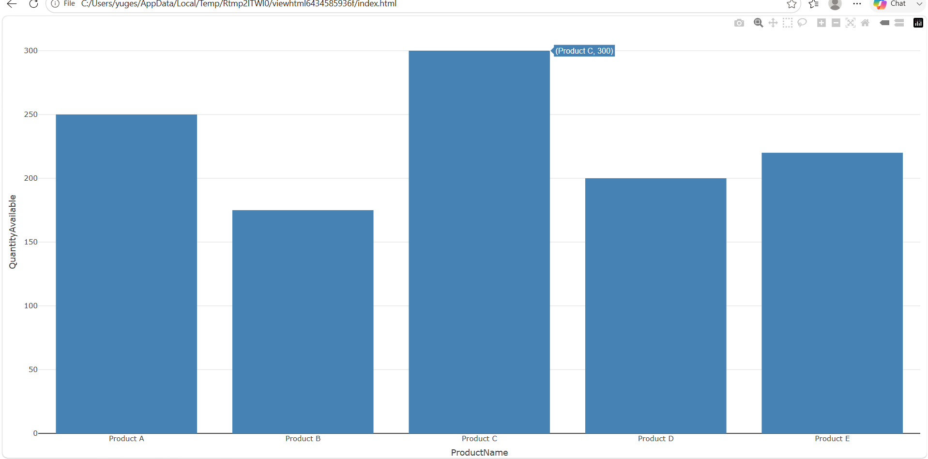

Set 5
Program 1: Line Chart – Daily Page Views Trend
Date <- c("2023-01-01","2023-01-02","2023-01-03","2023-01-04","2023-01-05")
PageViews <- c(1500,1600,1400,1650,1800)
CTR <- c(2.3,2.7,2.0,2.4,2.6)
data <- data.frame(Date, PageViews, CTR)
plot(PageViews,
type="o",
col="blue",
pch=16,
xaxt="n",
xlab="Date",
ylab="Page Views",
main="Daily Website Page Views")
axis(1,
at=1:5,
labels=data$Date)
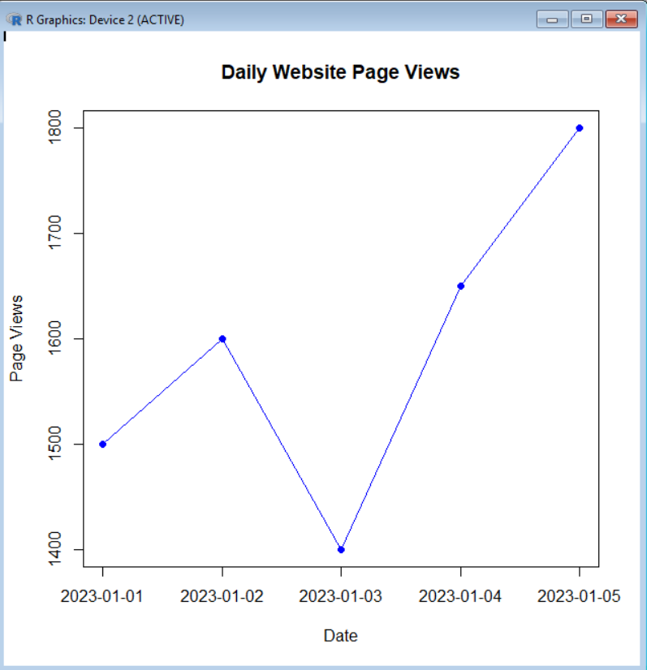
Output:

Program 2: Bar Chart – Click-through Rate (CTR)
Date <- c("2023-01-01","2023-01-02","2023-01-03","2023-01-04","2023-01-05")
PageViews <- c(1500,1600,1400,1650,1800)
CTR <- c(2.3,2.7,2.0,2.4,2.6)
data <- data.frame(Date, PageViews, CTR)
barplot(data$CTR,
names.arg=data$Date,
col="orange",
main="Click-through Rate by Date",
xlab="Date",
ylab="CTR (%)")

Output:
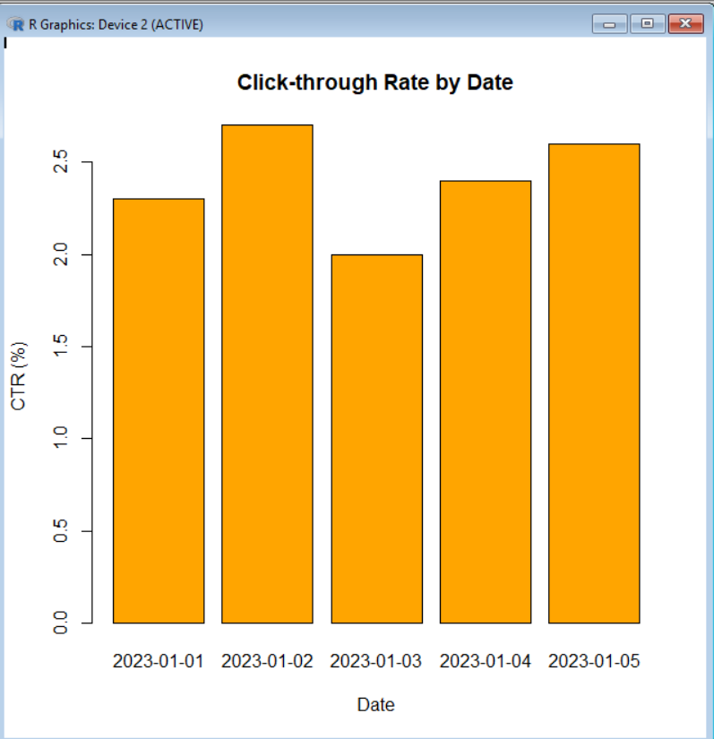

Program 3: Pie Chart – Distribution of Page Views
Date <- c("2023-01-01","2023-01-02","2023-01-03","2023-01-04","2023-01-05")
PageViews <- c(1500,1600,1400,1650,1800)
pie(PageViews,
labels=Date,
col=rainbow(5),
main="Distribution of Website Page Views")

Output:
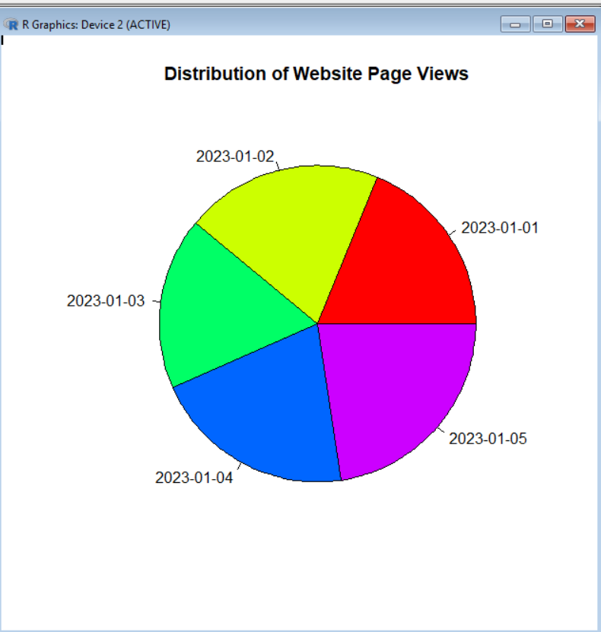

Program 4: Interactive Dashboard (Plotly)
library(plotly)
Date <- c("2023-01-01","2023-01-02","2023-01-03","2023-01-04","2023-01-05")
PageViews <- c(1500,1600,1400,1650,1800)
CTR <- c(2.3,2.7,2.0,2.4,2.6)
data <- data.frame(Date, PageViews, CTR)
fig <- plot_ly(data,
x=~Date,
y=~PageViews,
type="scatter",
mode="lines+markers",
name="Page Views")
fig

Output:
